**Mavenization using Eclipse M2E plugin Options and CLI commands**

**Problem Statement:**

  To understand Mavenization with two different options

– Use Eclipse M2E plugin Options

– Use CLI options

**Steps to execute:**

1. Work with Trainer to install m2e eclipse plugin as well as get Maven installed separately. The candidates should be able to mvn –version and successfully get the following output on the command shell.
2. Open Command Prompt and write “mvn –version”.

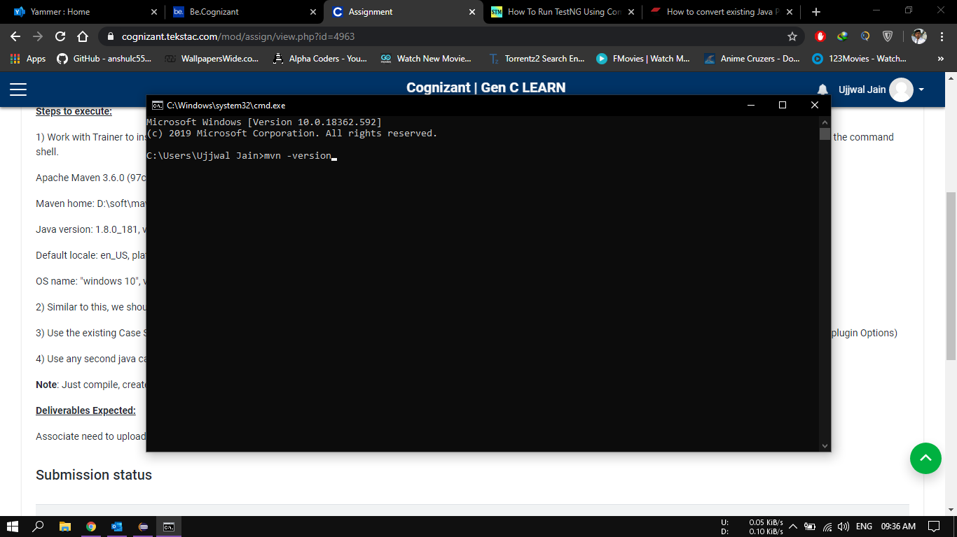

1. Click enter and the following output prints on Command Prompt.

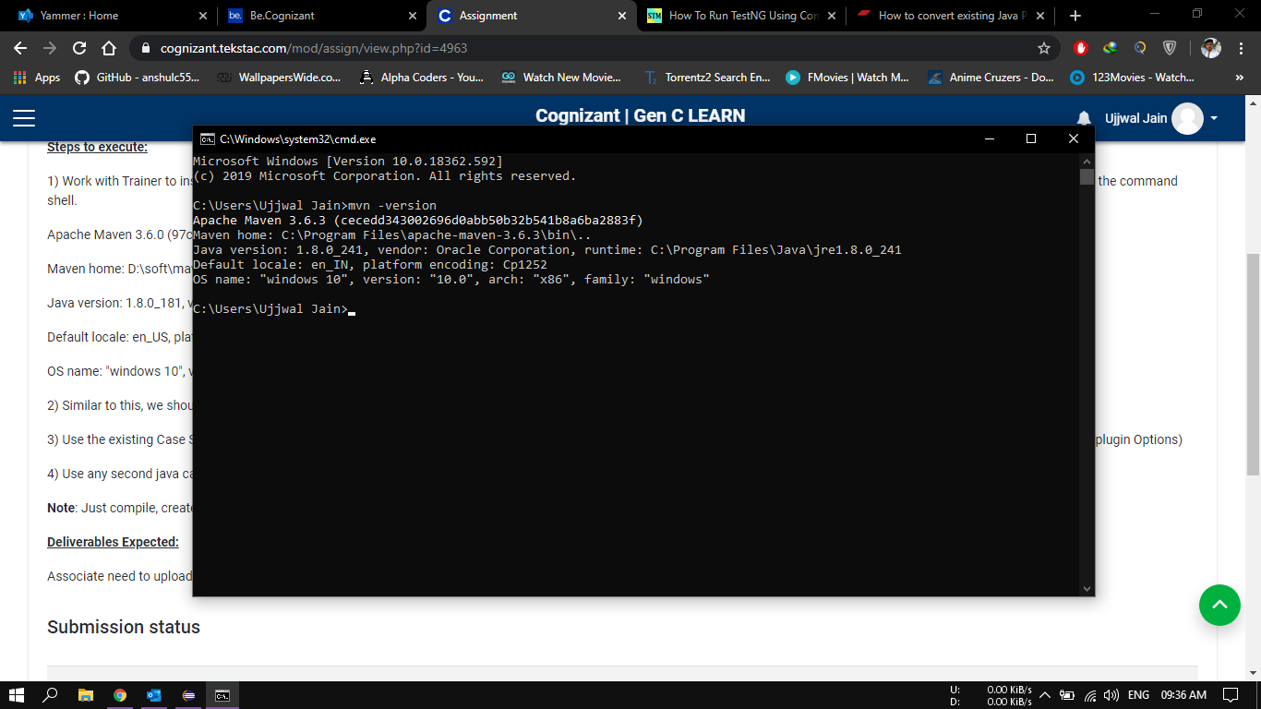

1. 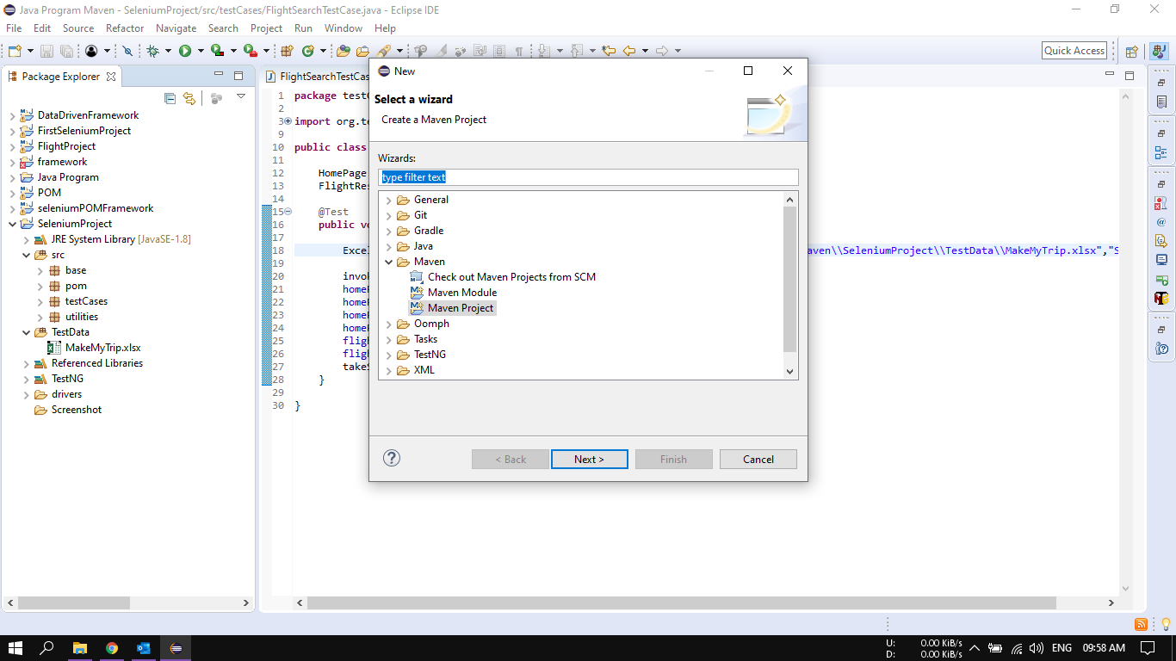Similar to this, we should see Maven options coming up on the context menu of the projects in the eclipse maven project.
2. Use the existing Case Study project or any of the eclipse project that you have created for the hands on. Use that eclipse project and demonstrate the mavenization(Use Eclipse M2E plugin Options).
3. 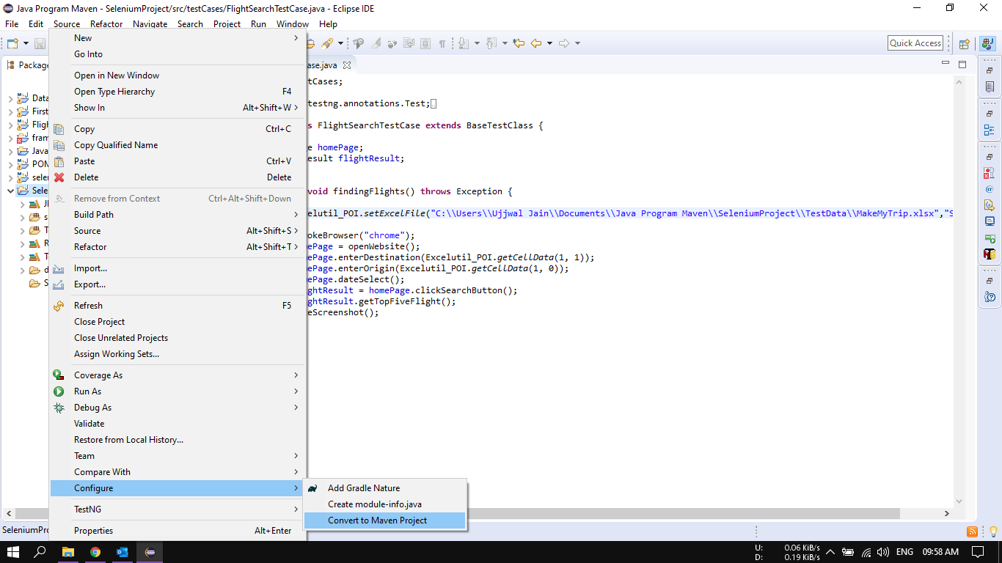Right click on the existing java project > Go to Configure > Go to Convert to Maven Project.
4. Click on Covert to Maven Project.

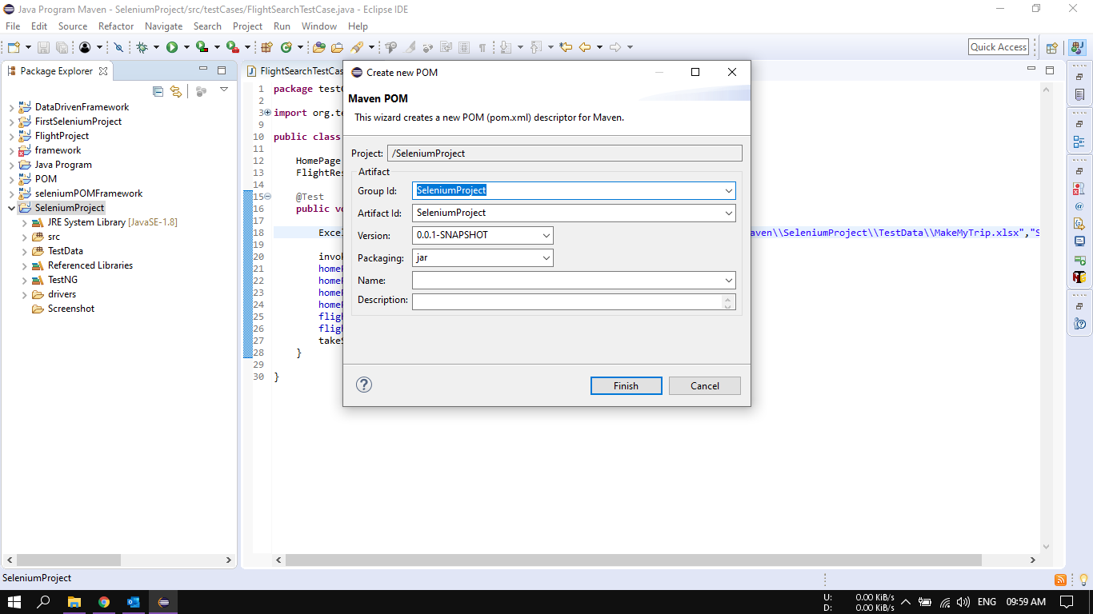

1. Enter the Group Id and Artifact Id and click on Finish. A “pom.xml” is created as shown below

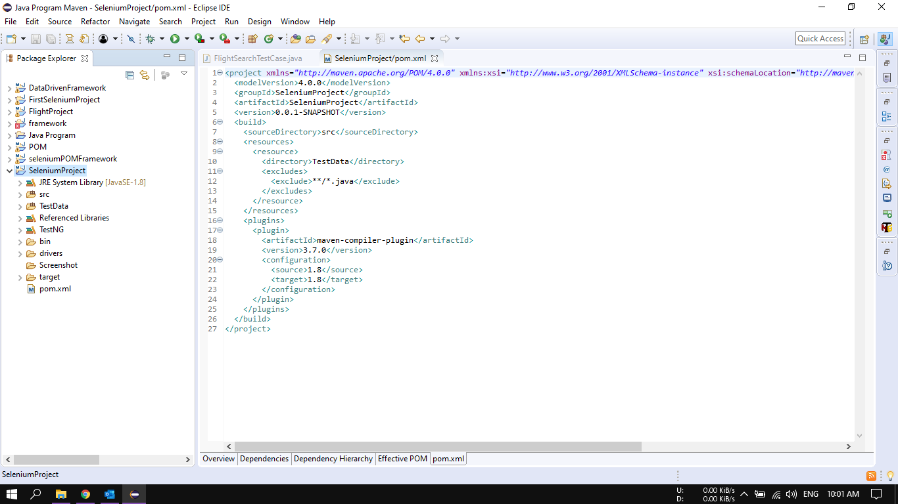

1. Use any second java case study project, apply CLI commands. Compile, test and run the project from the command shell.
2. Open Command Prompt and write following command and click enter :

**C:\Users\Ujjwal Jain\Documents\Java Program Maven\SeleniumProject>set classpath=C:\Users\Ujjwal Jain\Documents\Java Program Maven\SeleniumProject\bin;C:\Users\Ujjwal Jain\Documents\Java Program Maven\SeleniumProject\lib\\***

After that enter the following command and click enter:

**C:\Users\Ujjwal Jain\Documents\Java Program Maven\SeleniumProject>java org.testng.TestNG C:\Users\Ujjwal Jain\Documents\Java Program Maven\SeleniumProject\testng.xml**

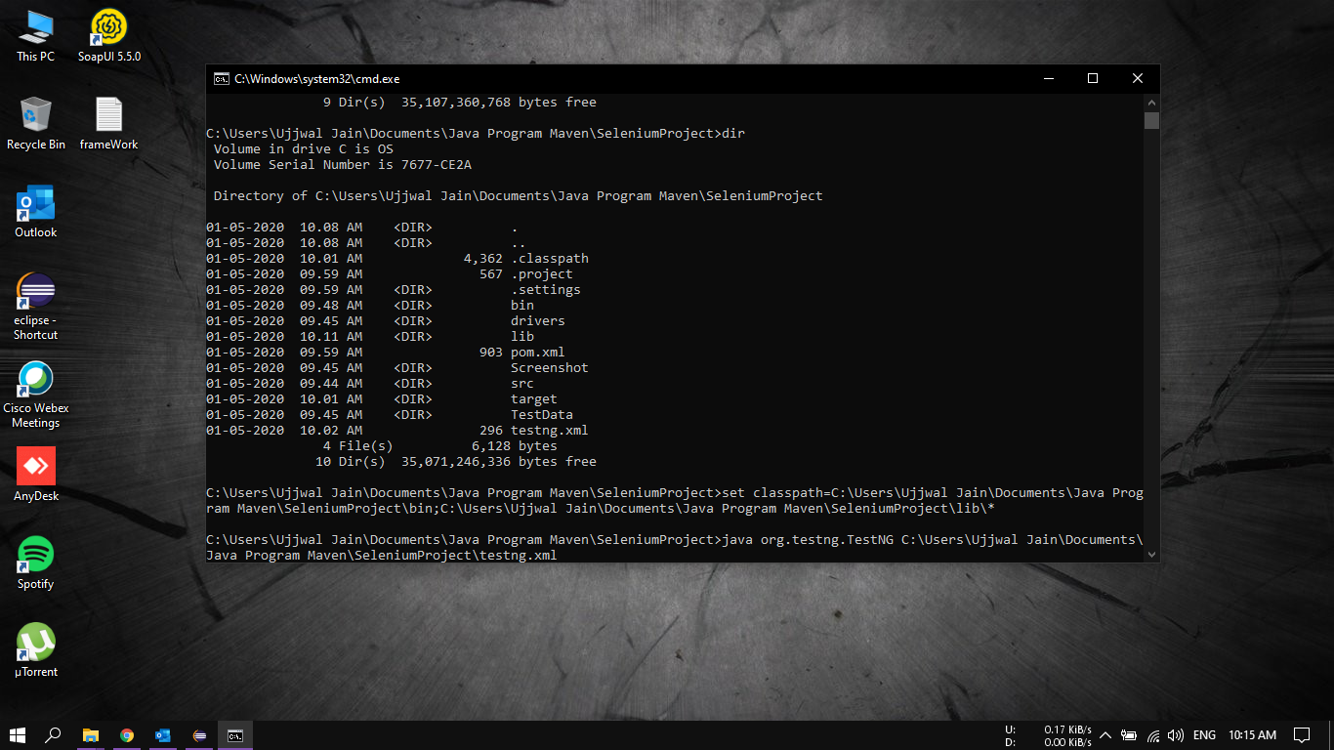

1. Following output will be generated.

